# **Python For Loops**

**Python For loop** is used for sequential traversal i.e. it is used for iterating over an iterable like string, tuple, list, etc. It falls under the category of **definite** iteration. Definite iterations mean the number of repetitions is specified explicitly in advance. In Python, there is no C style for loop, i.e., for (i=0; i<n; i++). There is “for in” loop which is similar to for each loop in other languages. Let us learn how to use for in loop for sequential traversals.

**Note:** In Python, for loops only implements the collection-based iteration.

**Syntax:**

for var in iterable:

# statements

### **Flowchart of for loop**

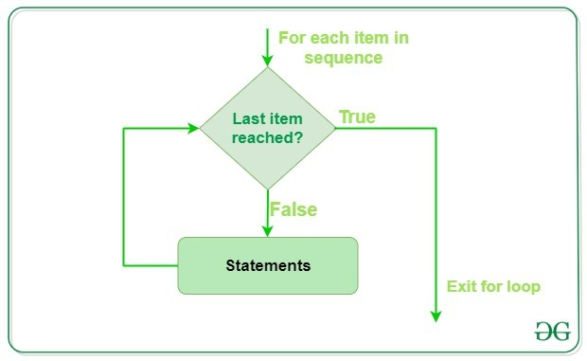

Here the iterable is a collection of objects like lists, tuples. The indented statements inside the for loops are executed once for each item in an iterable. The variable var takes the value of the next item of the iterable each time through the loop.

### **Example: Python For Loop using List, Dictionary, String**

|  |
| --- |
| # Python program to illustrate  # Iterating over a list  print("List Iteration")  l =["geeks", "for", "geeks"]  fori inl:      print(i)    # Iterating over a tuple (immutable)  print("\nTuple Iteration")  t =("geeks", "for", "geeks")  fori int:      print(i)    # Iterating over a String  print("\nString Iteration")  s ="Geeks"  fori ins:      print(i)    # Iterating over dictionary  print("\nDictionary Iteration")  d =dict()  d['xyz'] =123  d['abc'] =345  fori ind:      print("% s % d"%(i, d[i])) |

**Output:**

List Iteration

geeks

for

geeks

Tuple Iteration

geeks

for

geeks

String Iteration

G

e

e

k

s

Dictionary Iteration

xyz 123

abc 345

## **Loop Control Statements**

Loop control statements change execution from its normal sequence. When execution leaves a scope, all automatic objects that were created in that scope are destroyed. Python supports the following control statements.

### **Continue Statement**

Python [continue Statement](https://www.geeksforgeeks.org/python-continue-statement/) returns the control to the beginning of the loop.

### **Example: Python for Loop with Continue Statement**

|  |
| --- |
| # Prints all letters except 'e' and 's'  forletter in'geeksforgeeks':      ifletter =='e'orletter =='s':          continue      print('Current Letter :', letter) |

**Output:**

Current Letter : g

Current Letter : k

Current Letter : f

Current Letter : o

Current Letter : r

Current Letter : g

Current Letter : k

### **Break Statement**

Python [break statement](https://www.geeksforgeeks.org/python-break-statement/) brings control out of the loop.

### **Example: Python For Loop with Break Statement**

|  |
| --- |
| forletter in'geeksforgeeks':        # break the loop as soon it sees 'e'      # or 's'      ifletter =='e'orletter =='s':          break    print('Current Letter :', letter) |

**Output:**

Current Letter : e

### **Pass Statement**

The [pass statement](https://www.geeksforgeeks.org/python-pass-statement/) to write empty loops. Pass is also used for empty control statements, functions, and classes.

### **Example: Python For Loop with Pass Statement**

|  |
| --- |
| # An empty loop  forletter in'geeksforgeeks':      pass  print('Last Letter :', letter) |

**Output:**

Last Letter : s

## **range() function**

Python [range()](https://www.geeksforgeeks.org/python-range-function/) is a built-in function that is used when a user needs to perform an action a specific number of times. range() in Python(3.x) is just a renamed version of a function called [xrange()](https://www.geeksforgeeks.org/range-vs-xrange-python/) in Python(2.x). The range() function is used to generate a sequence of numbers. Depending on how many arguments user is passing to the function, user can decide where that series of numbers will begin and end as well as how big the difference will be between one number and the next.range() takes mainly three arguments.

* **start:** integer starting from which the sequence of integers is to be returned
* **stop:** integer before which the sequence of integers is to be returned.   
  The range of integers end at stop – 1.
* **step:** integer value which determines the increment between each integer in the sequence

### **Example: Python for loop with range function**

|  |
| --- |
| # Python Program to  # show range() basics    # printing a number  fori inrange(10):      print(i, end=" ")  print()    # using range for iteration  l =[10, 20, 30, 40]  fori inrange(len(l)):      print(l[i], end=" ")  print()    # performing sum of first 10 numbers  sum=0  fori inrange(1, 10):      sum=sum+i  print("Sum of first 10 numbers :", sum) |

**Output**0 1 2 3 4 5 6 7 8 9

10 20 30 40

Sum of first 10 numbers : 45

## **Python for loop with else**

In most of the programming languages (C/C++, Java, etc), the use of else statements has been restricted with the if conditional statements. But Python also allows us to use the else condition with for loops.

**Note:** The else block just after for/while is executed only when the loop is NOT terminated by a break statement

|  |
| --- |
| # Python program to demonstrate  # for-else loop    fori inrange(1, 4):      print(i)  else:  # Executed because no break in for      print("No Break\n")    fori inrange(1, 4):      print(i)      break  else:  # Not executed as there is a break      print("No Break") |

**Output:**

1

2

3

No Break

1

**Note:** For more information refer to our [Python for loop with else tutorial](https://www.geeksforgeeks.org/using-else-conditional-statement-with-for-loop-in-python/).